# ChatGPT created Threat Model

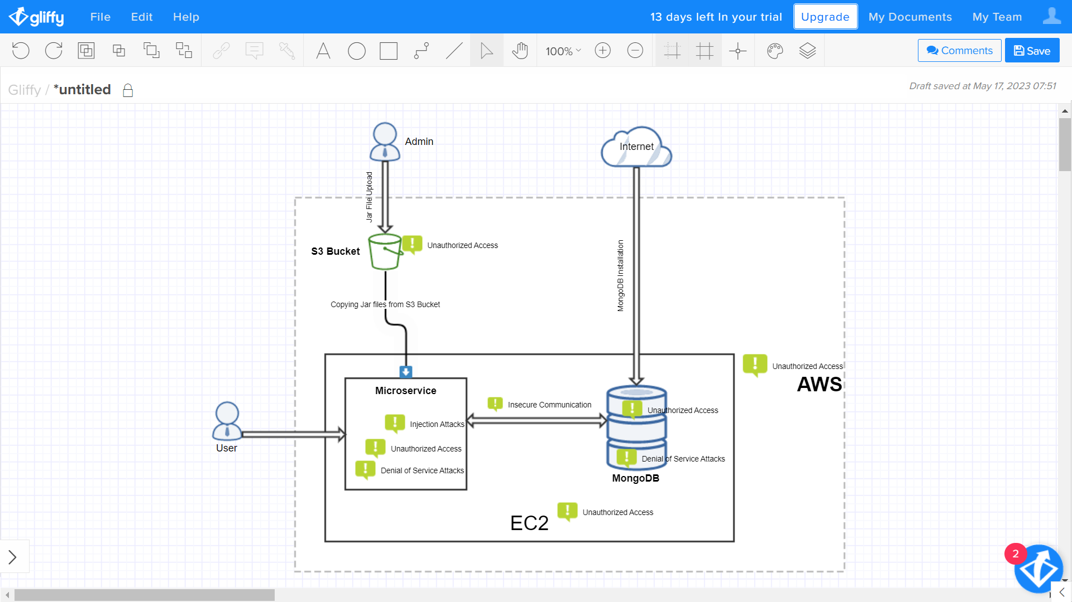

Figure 1: ChatGPT Created Threat Model

## Asking ChatGPT to create a threat model for my microservice application

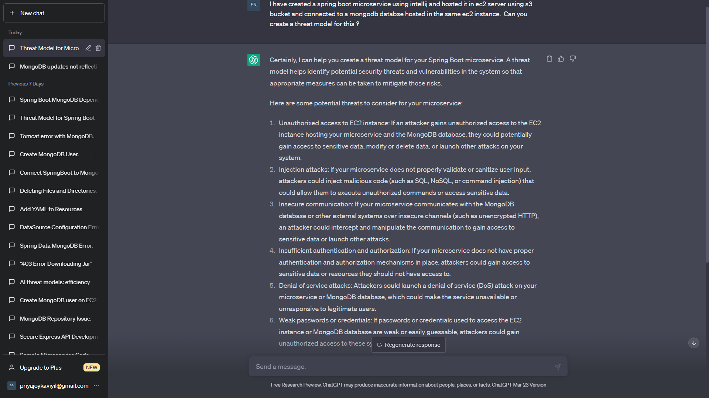

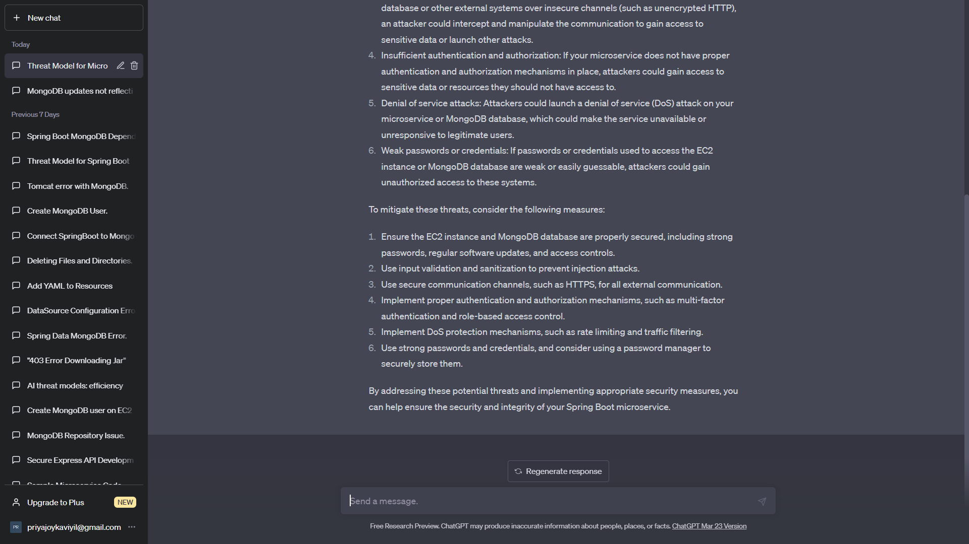

## Ensuring the security of EC2 instance and Mongo DB instance

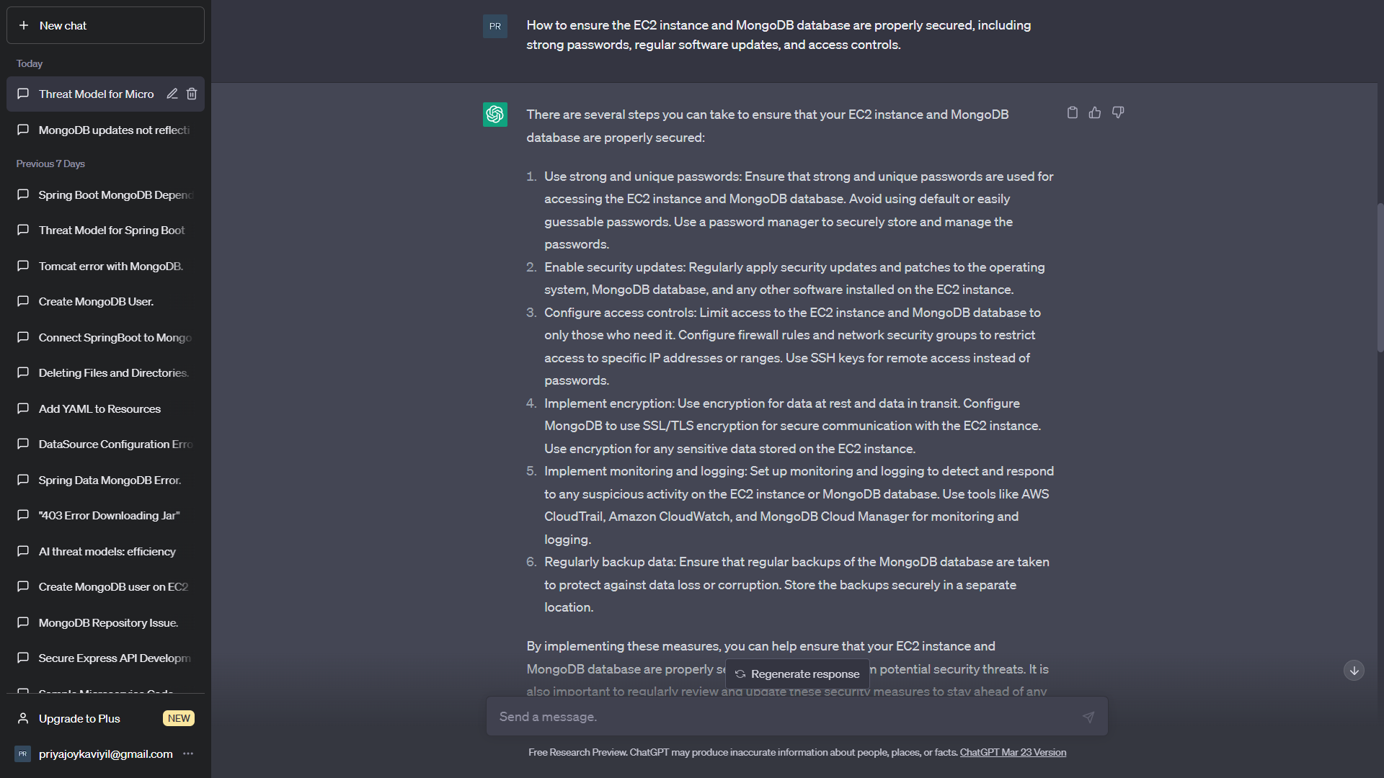

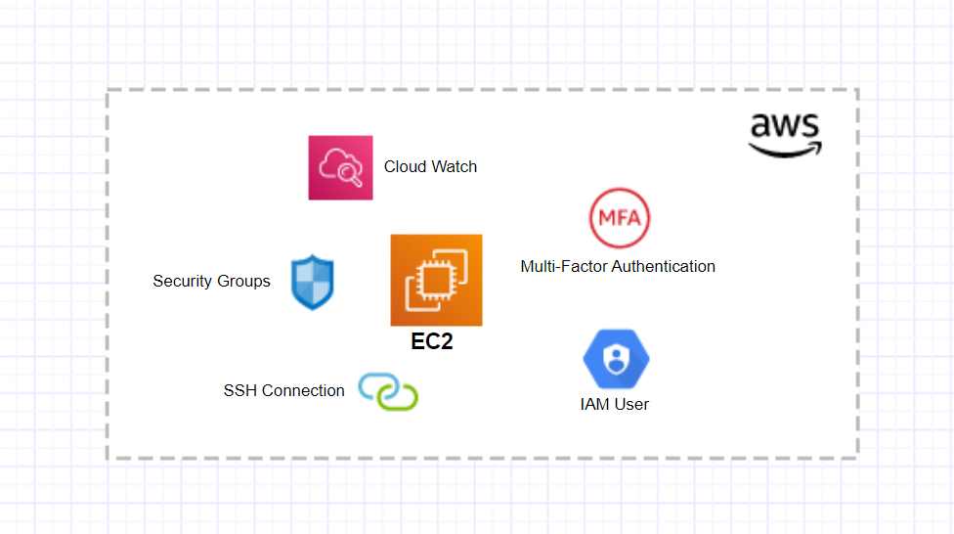

Figure 2: EC2 Threat Mitigation

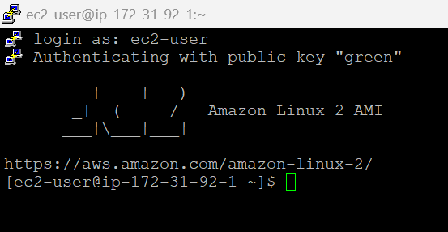

Figure 3: SSH connection using putty

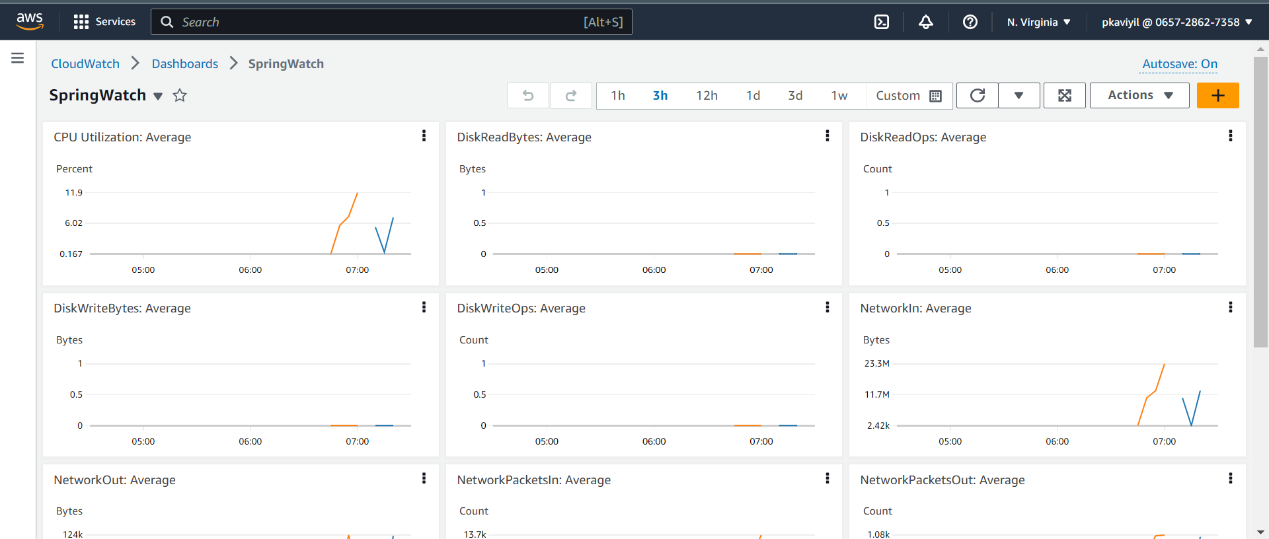

Figure 4: CloudWatch Monitoring

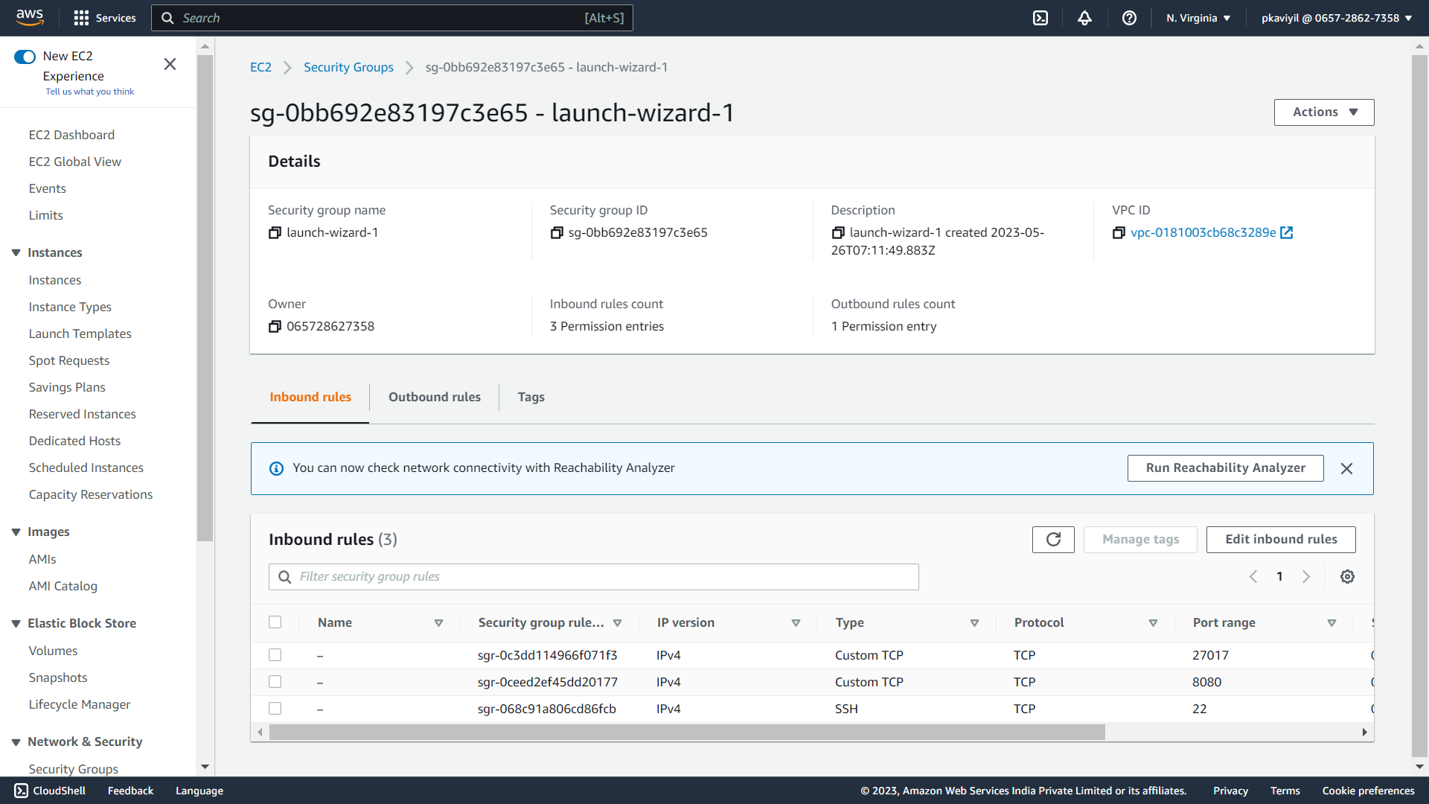

Figure 5: Security Groups

## Implementing multi-factor authentication and role-based access control

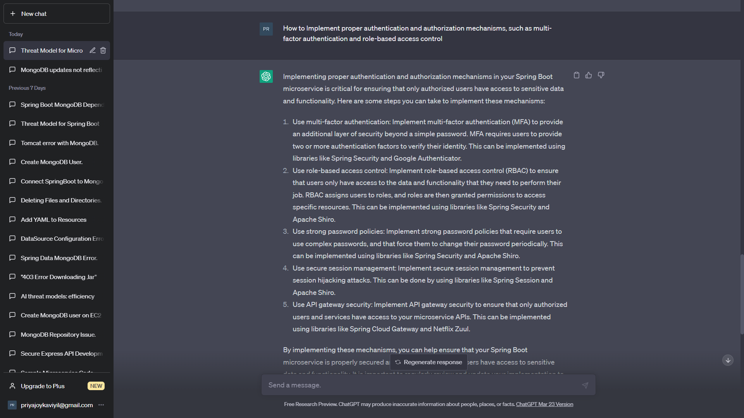

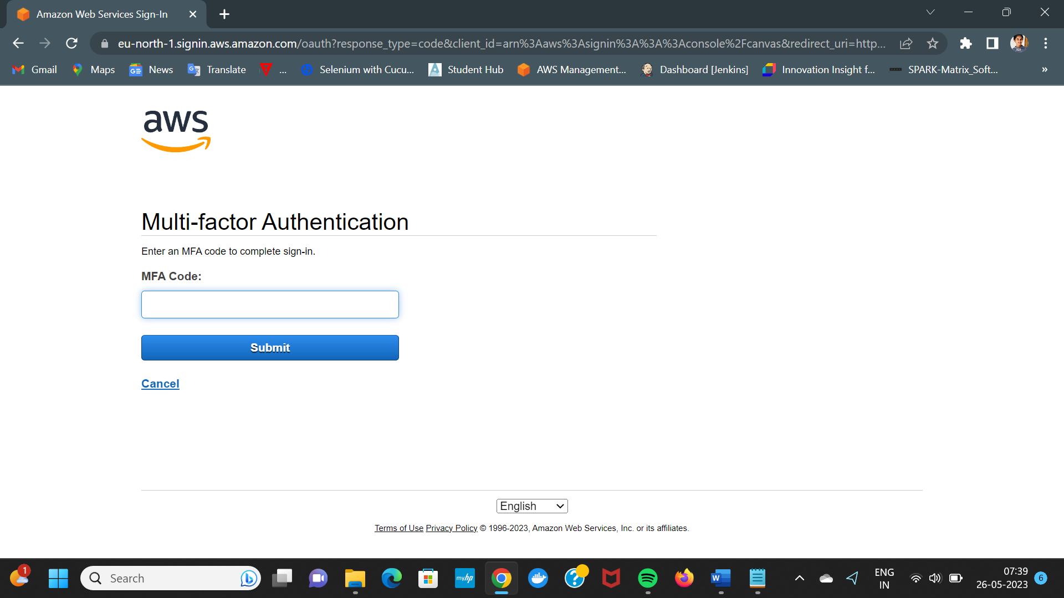

Figure 6: MFA Authentication

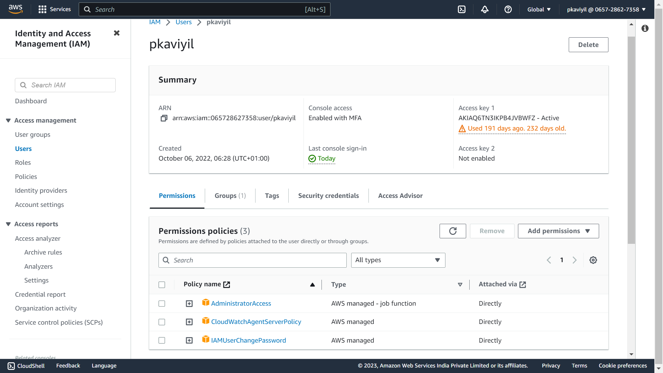

Figure 7: IAM user

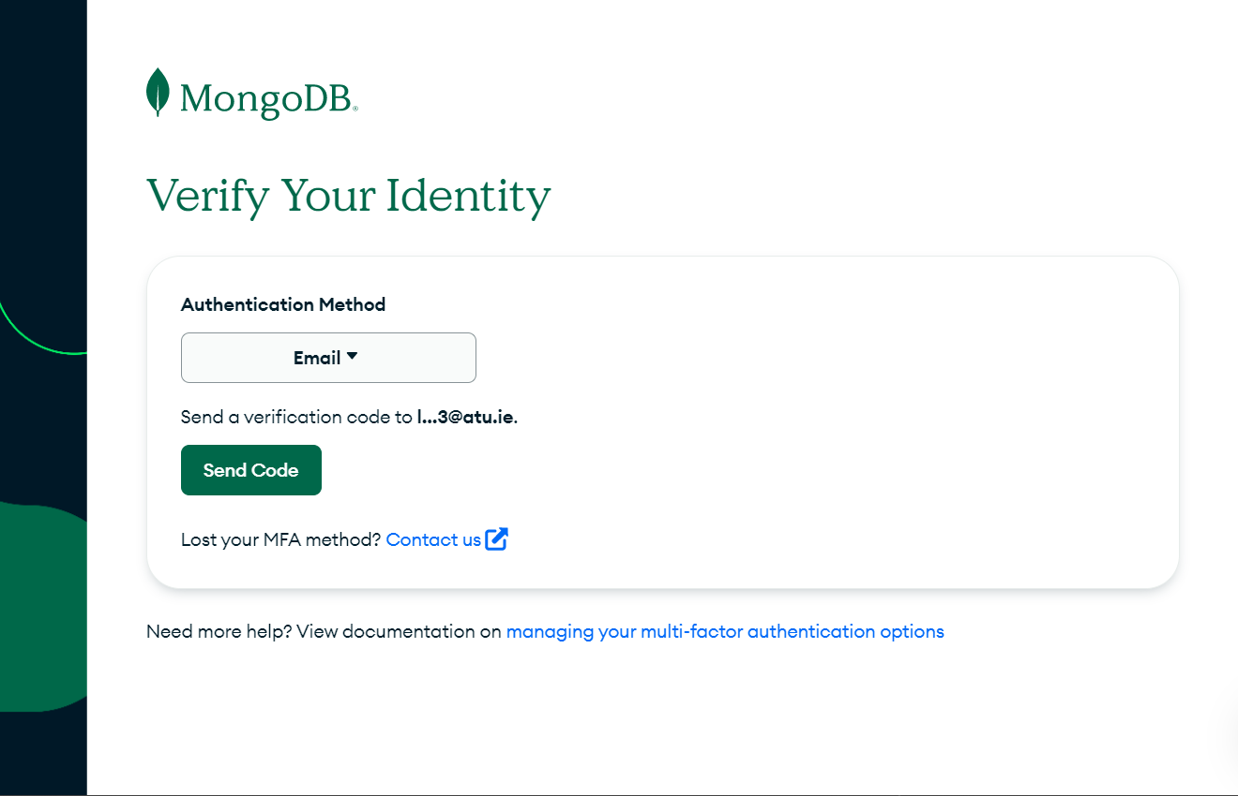

Figure 8: MongoDB Cloud MFA Authentication

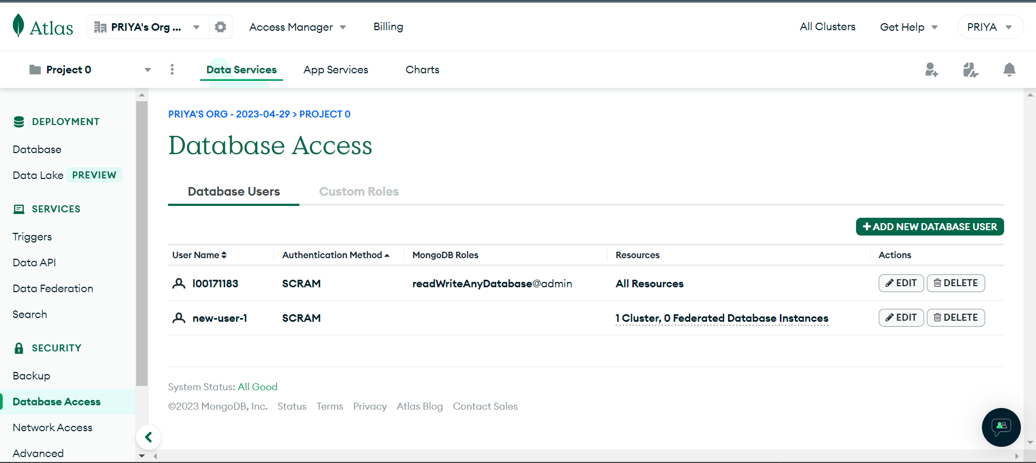

Figure 9: MongoDB Access Control

## Using input validation and sanitization to prevent injection attacks

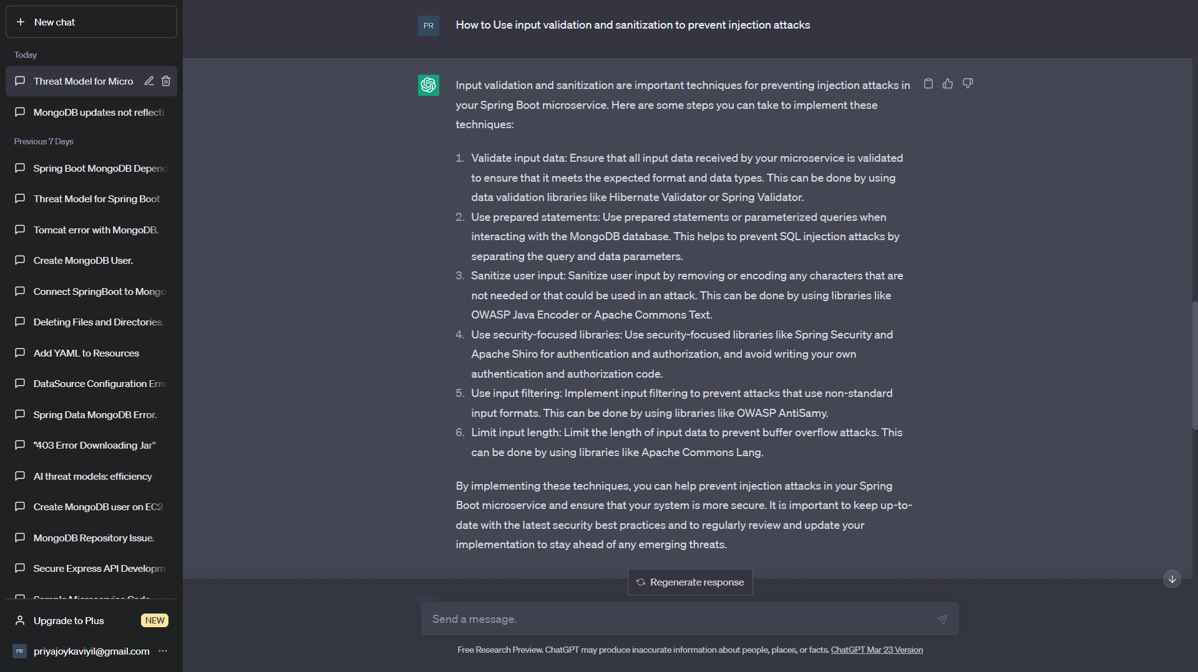

Using these libraries in the pom file.

<dependency>

<groupId>org.owasp.antisamy</groupId>

<artifactId>antisamy</artifactId>

<version>1.6.5</version>

</dependency>

<dependency>

<groupId>org.hibernate.validator</groupId>

<artifactId>hibernate-validator</artifactId>

<version>7.0.1.Final</version>

</dependency>

<dependency>

<groupId>org.apache.commons</groupId>

<artifactId>commons-lang3</artifactId>

<version>3.12.0</version>

</dependency>

## Implementing DoS protection mechanisms, such as rate limiting and traffic filtering

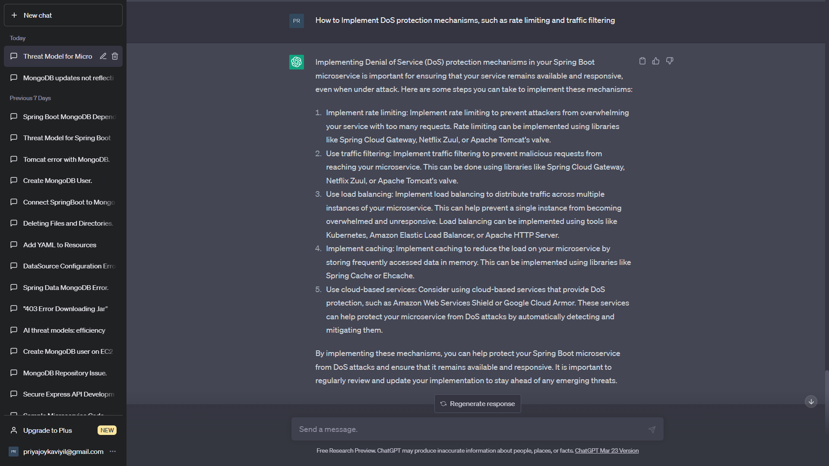

<dependency>

<groupId>org.springframework.cloud</groupId>

<artifactId>spring-cloud-starter-gateway</artifactId>

<version>3.0.4</version>

</dependency>

<dependency>

<groupId>org.springframework.boot</groupId>

<artifactId>spring-boot-starter-cache</artifactId>

<version>2.5.0</version>

</dependency>

GitHub Repo : <https://github.com/L00171183/ThreatModel/tree/main/demo>